5.2 Reading Tests
Following the determination of the required medical tests and their corresponding clinical values, a specialized subsystem was developed to automate the extraction of data from medical test report images. This subsystem leverages Optical Character Recognition (OCR) alongside Regular Expressions (Regex) to parse and digitize textual information efficiently.
The integration of these technologies serves two primary functions:
- Text Extraction (OCR): Converts the visual data from scanned or photographed medical reports into raw machine-readable text.
- Pattern Matching (Regex): Analyzes the extracted text to identify, isolate, and capture specific test names and their numerical results based on predefined formatting patterns.
5.2.1 OCR Libraries
There are numerous Optical Character Recognition (OCR) libraries available, with the three most prominent being Tesseract, EasyOCR, and docTR. To select the most accurate and suitable engine for reading medical analysis reports, we conducted two distinct evaluations.
The first evaluation was implemented based on the Ground Truth concept and with Confidence and accuracy performance measures:
- Ground Truth Establishment: This refers to the creation of an absolute reference text (baseline) used to evaluate and compare the accuracy of the text extracted by the three OCR libraries. This baseline text was generated with the assistance of Google Gemini, which was used to precisely extract and verify the original text directly from the medical report photos.
- Performance Metrics: Each OCR library was evaluated based on two primary metrics:
- Confidence Score: Measures the model's internal certainty regarding the accuracy of the extracted text. This was calculated as the average confidence score across all recognized tokens.

- Text Accuracy: Quantifies how closely the extracted text matches the established ground truth. This was evaluated using the Levenshtein Distance algorithm, which computes the minimum number of single-character edits (insertions, deletions, or substitutions) required to transform the OCR output into the ground truth text.
The first evaluation was applied to three images for Urine, Complete Blood Count (CBC), and Ferritin tests, with results in the following table
Tests / Library |  | Tesseract | EasyOCR | docTR
CBC | Confidence | 86.02% | 88.14% | 88.14%
 | Accuracy | 86.55% | 84.77% | 86.51%
Urine | Confidence | 81.04% | 94.10% | 96.14%
 | Accuracy | 31.46% | 87.64% | 90.79%
Ferritin | Confidence | 90.45% | 86.67% | 93.50%
 | Accuracy | 92.80% | 92.27% | 93.23%
Table: The difference between confidence and accuracy for the selected OCR library
The best results for the first evaluation go for the docTR library.
The second evaluation focused on testing the impact of image pre-processing techniques on OCR performance and whether it improves the performance of the Tesseract or EasyOCR libraries. For each medical report, multiple variations of the test image were generated. Each image was first converted to grayscale and then subjected to one of the following individual operations:
- Resizing via Cubic Interpolation: To enhance spatial resolution.
- Contrast Limited Adaptive Histogram Equalization (CLAHE): To improve local contrast and highlight text boundaries.
- Adaptive Thresholding: To binarize the image and isolate text from the background.
Each modified version was stored as a separate image within a list variable named variations.
These generated variations were then processed using Tesseract and EasyOCR. The system evaluated the outputs and printed the optimal text version for each report, which was selected based on having the lowest occurrence of random symbols or character recognition errors.

Finally, the best texts obtained from Tesseract and EasyOCR were manually compared against the baseline performance of docTR, which processed the original, unmodified images. It was observed that docTR operating on the natural, unaltered images consistently produced the fewest errors, yielding the most stable and accurate text extraction, as explained in the following images:
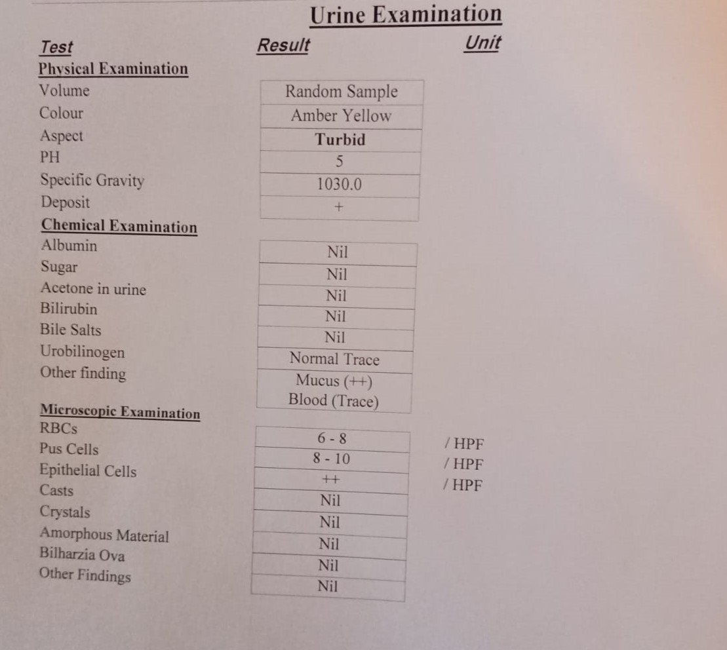
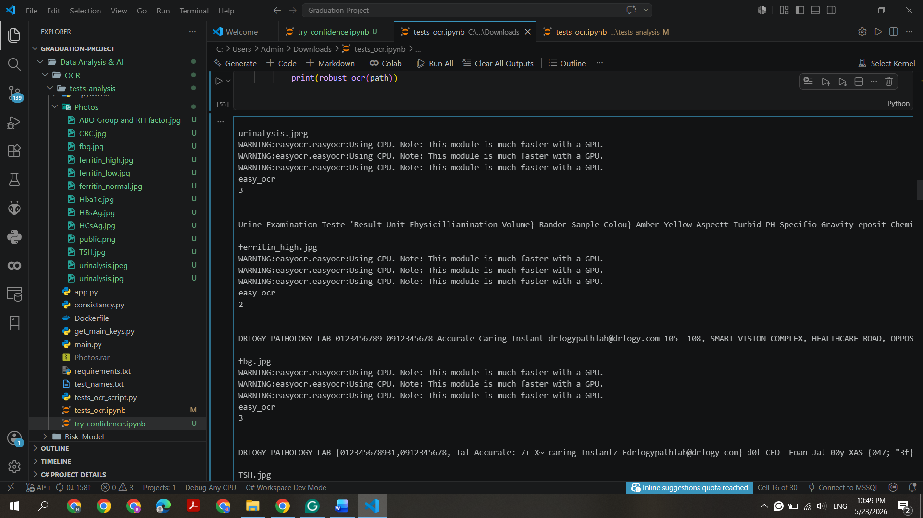
Figure: Part of Original Urine Photo
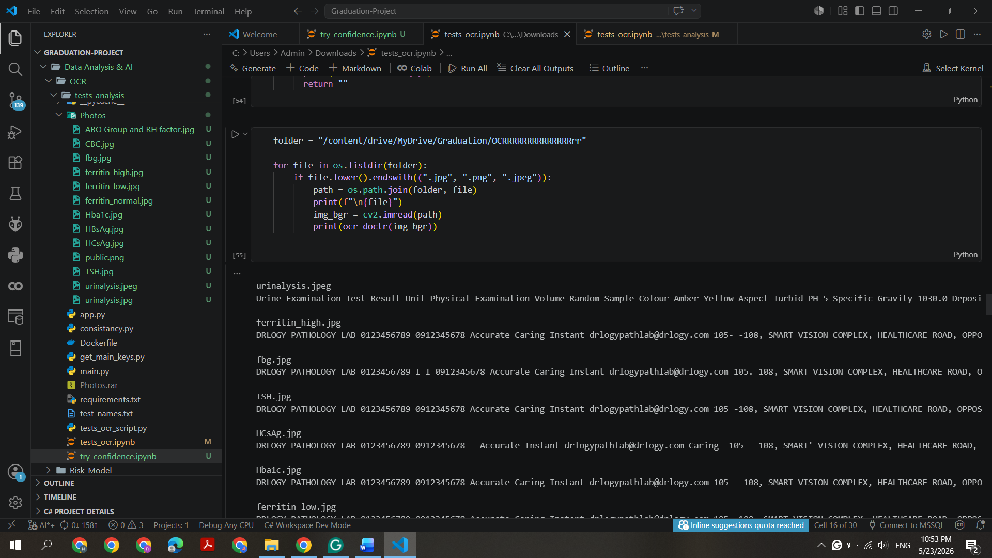
Figure: The EasyOCR best result with threshold variation for the urine test and its errors.
Figure: The DocTR result with the normal urine test photo and the corrected errors.
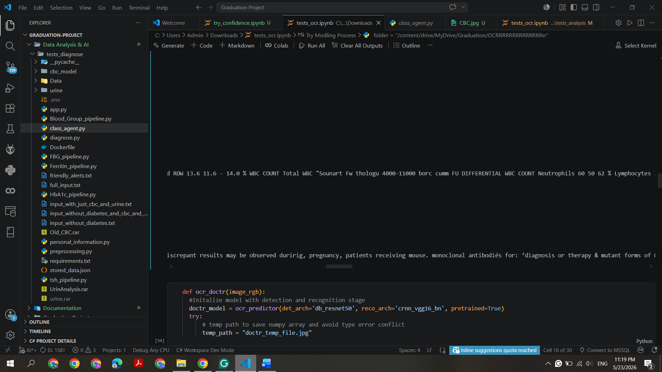
Figure: Part of Original CBC Photo
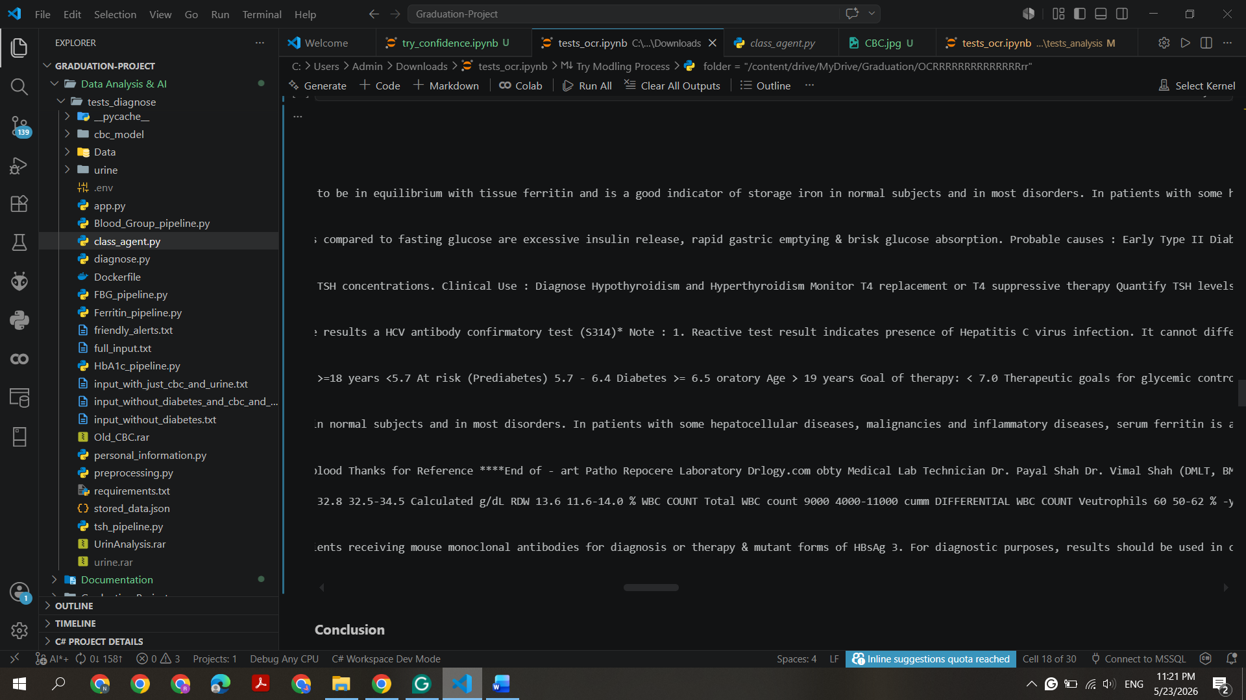
Figure: The EasyOCR best result with CLACHE variation for the CBC test and its errors
Figure: The DocTR result with the normal CBC test photo and the corrected errors.
Based on the findings of both evaluations, docTR was selected as the primary OCR engine for the Nabd ecosystem due to its superior accuracy and robustness with unaltered medical tests.
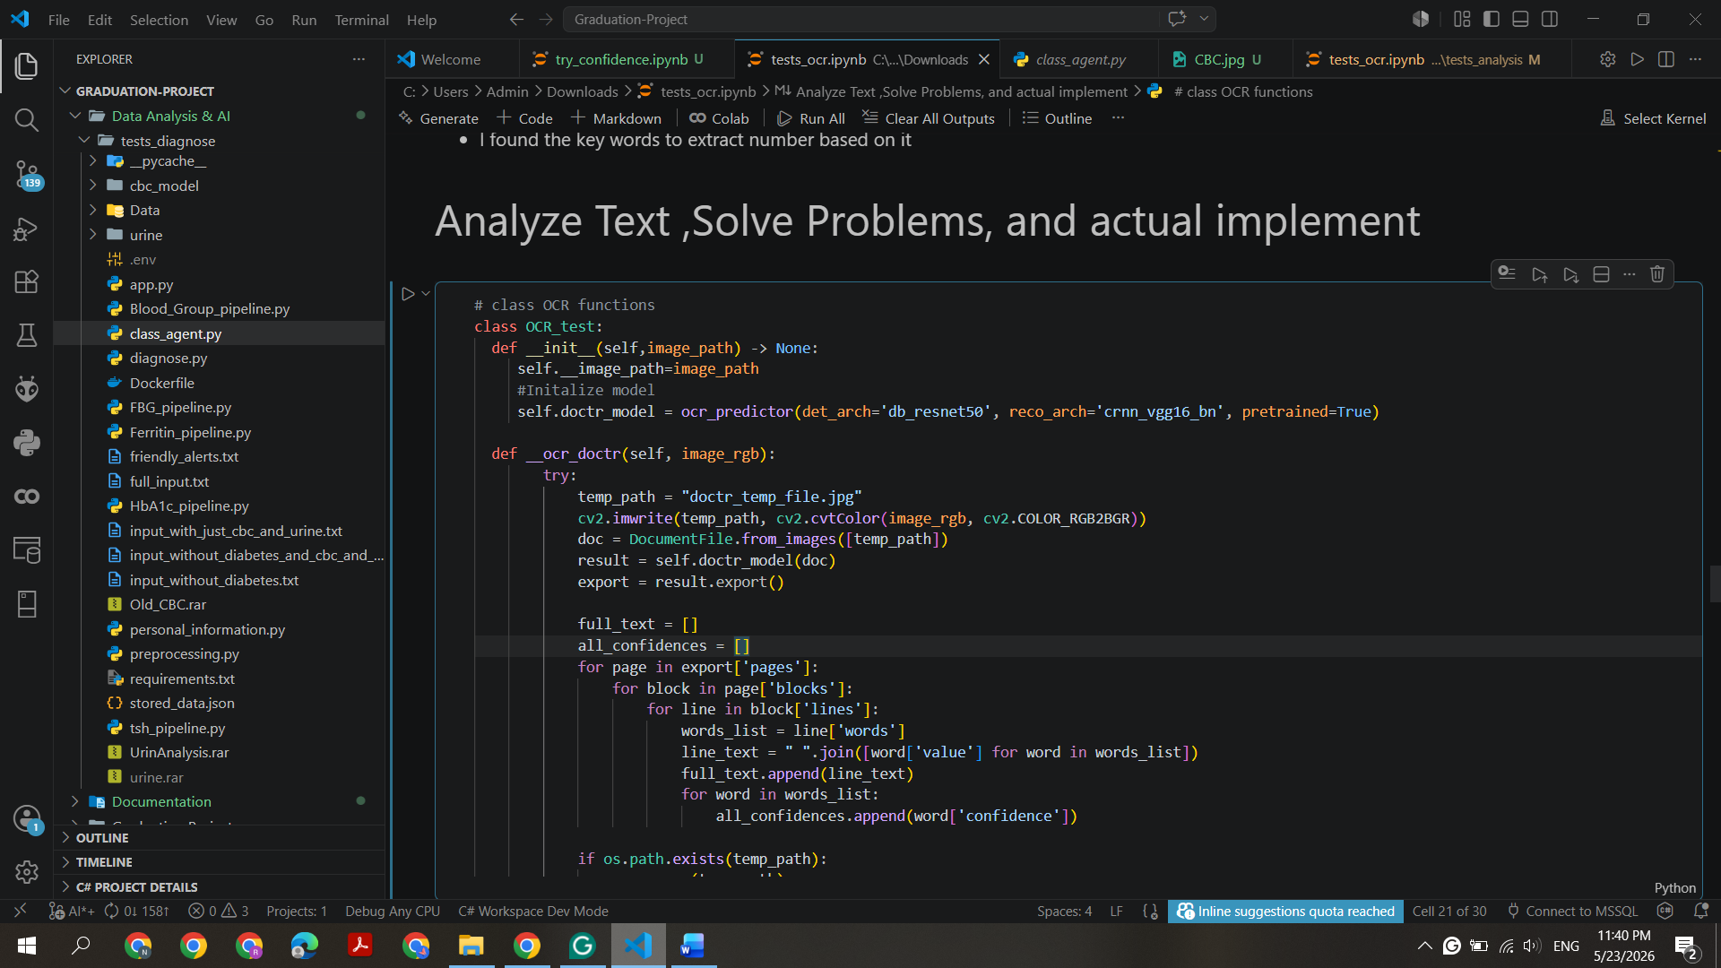
The library was integrated into the subsystem using a specific high-performance pipeline configuration, defined as follows:
Figure: Represent the DocTR selected model.
This configuration utilizes a two-stage deep learning architecture:
- Text Detection (det_arch): Employs the Real-time Scene Text Detection with Differentiable Binarization (DBNet) with a ResNet-50 backbone to precisely locate text bounding boxes within the medical report.
- Text Recognition (reco_arch): Utilizes a Convolutional Recurrent Neural Network (CRNN) paired with a VGG-16 backbone and Batch Normalization (vgg16_bn) to accurately decode the characters from the detected text regions.
5.2.2 Regular Expression (Regex)
Once the raw text is extracted via the docTR OCR engine, the next critical step is information extraction and data structuring. Since medical laboratories often use different naming conventions and layouts for the same test components, a standard keyword matching approach is insufficient. To address this, Regular Expressions (Regex) were utilized to dynamically scan and parse the text based on predefined structural patterns.
A comprehensive analytical study was conducted on all required medical test parameters to map their variations. This study focused on three main dimensions:
- Naming Variations: Identifying the different synonyms or abbreviations used for a single test (e.g., White Blood Cells can appear as WBC, WBCs, or White Blood Count).
- Structural Formatting: Analyzing the specific formatting and positioning of the results relative to the test names, allowing the pattern to accurately isolate the value regardless of the surrounding text layout.

- Outcome Variations: Accounting for different result types, which include:
- Numerical Results: Capturing integers and floating-point (decimal) numbers.
- Textual Results: Detecting qualitative text indicators such as Reactive, Non-reactive, Positive, Negative, or Null.
Based on this analysis, robust Regex patterns were engineered to accurately capture and isolate the test names alongside their corresponding numerical or textual values, while filtering out unrelated textual noise.
The following table details each medical test along with its specific target parameters, the expected numeric or textual outcomes, and their corresponding regular expression patterns.
Tests | Values | Target Parameter | Outcome
CBC | Hemoglobin | hemoglobin  |hb | Float Number
 | Red Blood Cell (RBC) Count | rbc  | red blood cell | Float Number
 | Mean Corpuscular Volume (MCV) | mcv  | mean  corpuscular volume | Float Number
 | Mean Corpuscular Hemoglobin (MCH) | mch|  mean corpuscular hemoglobin | Float Number
 | Red Cell Distribution Width  (RDW) | rdw| red cell distribution width | Float Number
 | White Blood Cells  (WBCs) | wbc |white blood cell |leucocytes | Integer Number
 | lymphocytes | lymph |lymphocytes | Float Number
 | Platelet count | platelet | plt | Integer Number
Urinalysis | Color | colour |color | The yellow color degree ranges from yellow to amber.
 | PH | ph | Float Number
 | Specific Gravity | specific gravity| gravity | Float Number
 | Protein | protein | albumin | Number | neg| nil| none| trace| small| moderate| large| |pos|present | +|++|+++|++++
 | Glucose | glucose |sugar | Number | neg| nil| none| trace| small| moderate| large| |pos|present | +|++|+++|++++
 | Nitrite | nitrite | Number | neg| nil| none| trace| small| moderate| large| |pos|present | +|++|+++|++++
 | Ketones | ketones| acetone| bcta-hydroxybutyrate| kctoncs | Number | neg| nil| none| trace| small| moderate| large| |pos|present | +|++|+++|++++
 | Blood | blood | Number | neg| nil| none| trace| small| moderate| large| |pos|present | +|++|+++|++++
Hemoglobin A1c or glycated hemoglobin (HbA1c) | HbA1c | hba1c|a1c|glycosylated | Float Number
Fasting Blood Glucose (FBG) | FBG | fasting| fbs |fbg |glucose |sugar | Float Number
Blood Group Test | ABO_Group | Blood group| abo group|abo | [ABO]{1,2}
 | RH_Factor | rh factor |rh | [\+\]|pos|neg|positive|negative
Thyroid-Stimulating Hormone (TSH) | TSH | tsh| s.tsh| thyrotropin| thyroid stimulating hormone | Float Number
Ferritin | Ferritin value | ferritin| s.ferritin | Float Number
Hepatitis C Virus (HCV) | HCV | hcv| anti hcv|hepatitis c | (non-reactive| reactive| negative| positive| neg| pos)
Hepatitis B surface antigen (HBsAg) | HBsAg | hbsag| antigen| hepatitis b surface | (non-reactive| reactive| negative| positive| neg| pos)
Table: The table defines medical tests, their parameters, and the outcome expected.
5.2.3) Subsystem Technical Implementation
The technical architecture of the text extraction subsystem is built upon Object-Oriented Programming (OOP) principles to ensure modularity, scalability, and clean separation of concerns. The pipeline is driven by three primary classes, followed by a rigorous two-step verification mechanism to ensure data integrity before persistence.
Core Architectural Classes
- OCR_test (Data Acquisition & Normalization):
This class is responsible for loading the input image and executing the deep learning docTR model to extract the raw text and model confidence. To optimize the downstream parsing efficiency, the class performs textual normalization through two steps:
- Converting the entire text to lowercase (.lower()).
- Stripping unrelated metadata by truncating the text to start from the keyword "unit". Since "unit" consistently appears within the header row of medical reports, removing everything prior to it filters out administrative noise (such as laboratory names or patient info) and isolates the actual clinical values for the Regex engine.
- test_parameters (Rule Definition):
As detailed in the previous section, this class acts as the centralized repository for medical patterns. It defines the specific clinical parameters and maps them to their respective regular expressions based on the selected test type.

- extract_test_values (Execution & Extraction):
This class handles the execution layer. It instantiates the parameters defined in test_parameters and applies them systematically against the normalized text output from OCR_test to extract the raw results.
Two-Step Verification Pipeline
To guarantee that the extracted clinical data is structurally sound and semantically accurate, a Two-Step Verification Pipeline was implemented using two dedicated modules: Completeness and Consistency.
Step 1: Completeness Verification
Before presenting the extracted data to the user, the Completeness module scans the output dictionary to check for missing fields. If a target medical parameter cannot be detected by the Regex engine, the system automatically assigns a standardized default placeholder based on the expected data type:
- String/Qualitative Fields: Assigned value is "Not Extracted".
- Numerical Fields: Assigned a default flag of -1.
Following this step, the structured results are displayed via the User Interface (UI). To ensure absolute clinical accuracy, the user is granted full authorization to review, verify, and manually amend any missing or incorrectly parsed values.
Step 2: Consistency Verification & Standardization
Once the user reviews the data and triggers the Confirm action, the payload is passed to the Consistency module before database insertion. This module is responsible for semantic normalization and categorical mapping:
- Qualitative synonyms or varying lab abbreviations (non-reactive, nil, negative, neg) are unified into a single, standardized canonical database token: negative.
- Similarly, variations like reactive, positive, or pos are mapped directly to positive.
Once the data is successfully validated, cleaned, and standardized, it is securely transmitted and stored in the ecosystem's centralized database.

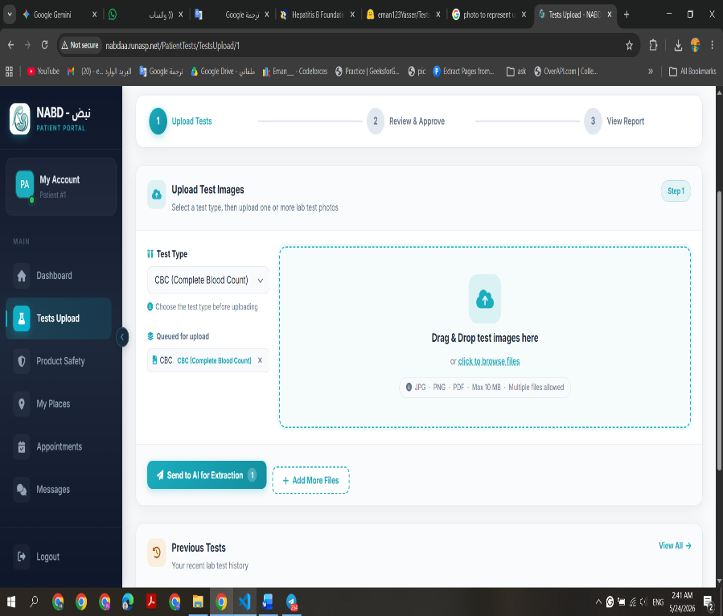
Text , confidence
OCR_test Class

Test Parameters , regex
test_parameters Class

extract_test_values Class
Class

UI Values
Extracted Values
Completeness Module
2-Step Verification Process
Extracted Values
Upload Image Process
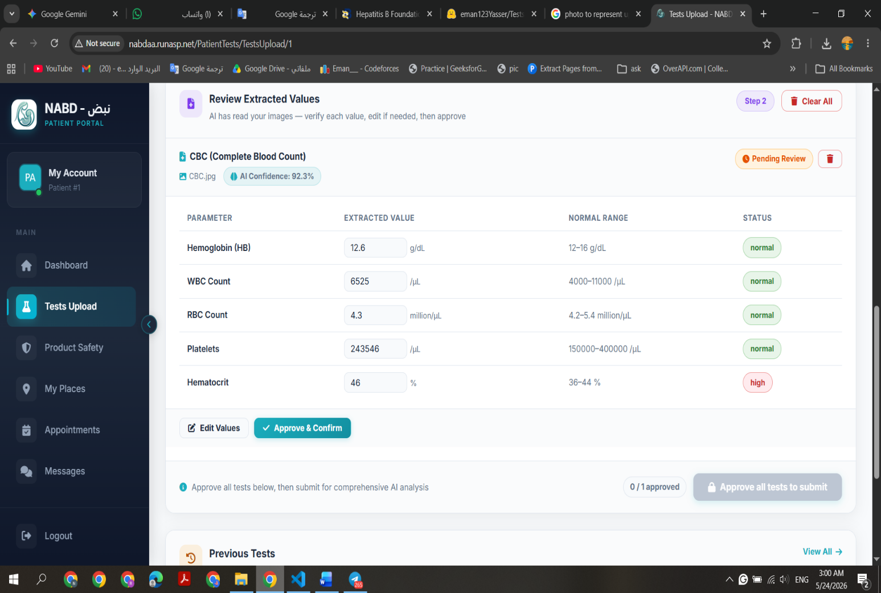

System Database
Consistent Values
Consistency Module
User Confirm

Figure: Represent Reading Values Processes.

